e|d0f k|ltj]bg
e|d0fdf ;+nUg sd{rf/Lx¿ M tf/f s'df/ >]i7, pk–dxflgb]{zs, s[lif ljefu
8f= km0fLGb|/fh b]jsf]6f, jl/i7 afnL ;+/If0f clws[t, s[lif ljefu
e|d0fsf] p2]Zo M /]zdv]tL ljsf; s]Gb|, ;'k/hf]g / cGo sfo{qmd cg'udg lg/LIf0f÷cjnf]sg tyf ;dGjo;DaGwL .
e|d0f cjlw M lj=;+= @)&%÷^÷@% b]lv @( ut];Dd .
e|d0f u/]sf] lhNnf M sfe|]knf~rf]s
cjnf]sg lg/LIf0fsf] ljj/0f M
s[lif ljefusf] cfb]z jdf]lhd o; cjlwdf /]zdv]tL ljsf; s]Gb|, vf]kf;L,s[lif 1fg s]Gb| -;fljs lh=s[=lj=sf=_ / cfn' ;'k/hf]g ;d]t lgsfox¿sf] canf]sg u/L ;+rflnt sfo{qmd ultljlwx¿ af/] 5nkmn, tyf ;dGjofTds cGt/lqmof ul/of] .
-s_ /]zdv]tL ljsf; s]Gb|, vf]kf;L, sfe|]
/]zdv]tL ljsf; s]Gb|, vf]kf;Ldf k|d'v >L r'8fdl0f e§/fO{ ;d]t s]Gb|sf ;a}h;f] sd{rf/Lx¿;+u ;+rflnt sfo{qmd ultljlw ;DaGwdf 5nkmn ul/of] . lg/LIf0f, cjnf]sg / 5nkmnaf6 lgDgfg';f/ hfgsf/L k|fKt eof] .
- gofF ;+u7g ;+/rgfdf of] /]zdv]tL ljsf; s]Gb| ;ª\3 cGt/ut k/]sf], t/ cGo /]zd kmfd{ s]Gb|x¿ k|b]z cGt/ut k/]sfn] ;dGjofTds sfo{qmd sfof{Gjogdf sl7gfO kg{ ;Sg] / ljz]if u/L /]zdaLh pTkfbg sfo{qmd ;'rf? ug{ cGo kmfd{ s]Gb|af6 aLhsf]of Nofpg'kg]{ ePsfn] k|efljt x'g ;Sg] dx;'; ul/Psf] .
- gofF ;+/rgf ;DaGwL s'g} cflwsfl/s kl/kq klg k|fKt gePsf] .
- sd{rf/Ln] tnj vfg] Joj:yf e};s]sf] .
- kof{Kt sfo{qmd ah]6 gePsfn] k'/fgf] au}Frf Joj:yfkg nufotsf lgoldt sfo{ ;Dkfbgdf ;d:of ePsf]] .
- o; s]Gb|sf /]zdaLh pTkfbg, dft[;|f]t ;+/If0f nufotsf sfo{ lgoldt / Joj:yfksLo sfo{ ;'rf? ug{ sfo{qmd jh]6 ck'u ePsf]n] yk sfo{qmd jh]6sf nflu k|:tfjgf l6Kk0fL ;lxt dfu u/L k7fOPsf]n] o;df ljefu÷dGqfnoaf6 ;xof]usf] ck]Iff ul/Psf] .
- /]zd aLhsf]of pTkfbg tyf ls/fkfng sfo{ xfn e}/x]sf] / lsDa' au}Frfx¿sf] Joj:yfkgdf s]xL sdL b]lvP klg lsDa'sf hflto ;+/If0fsf sfo{ eO{ /x]sf] hfgsf/L eof] .
- /]zd l/lnË -wfuf] pTkfbg_ sf/vfgfdf ljutb]lv cTofw'lgs k|lalwsf d]lzg pks/0fx¿ pknAw eP klg xfn hL0f{ cj:yfdf /x]sf] / ;'rf? x'g g;s]sf] .
- cGo ultljlw ;fdfGo .
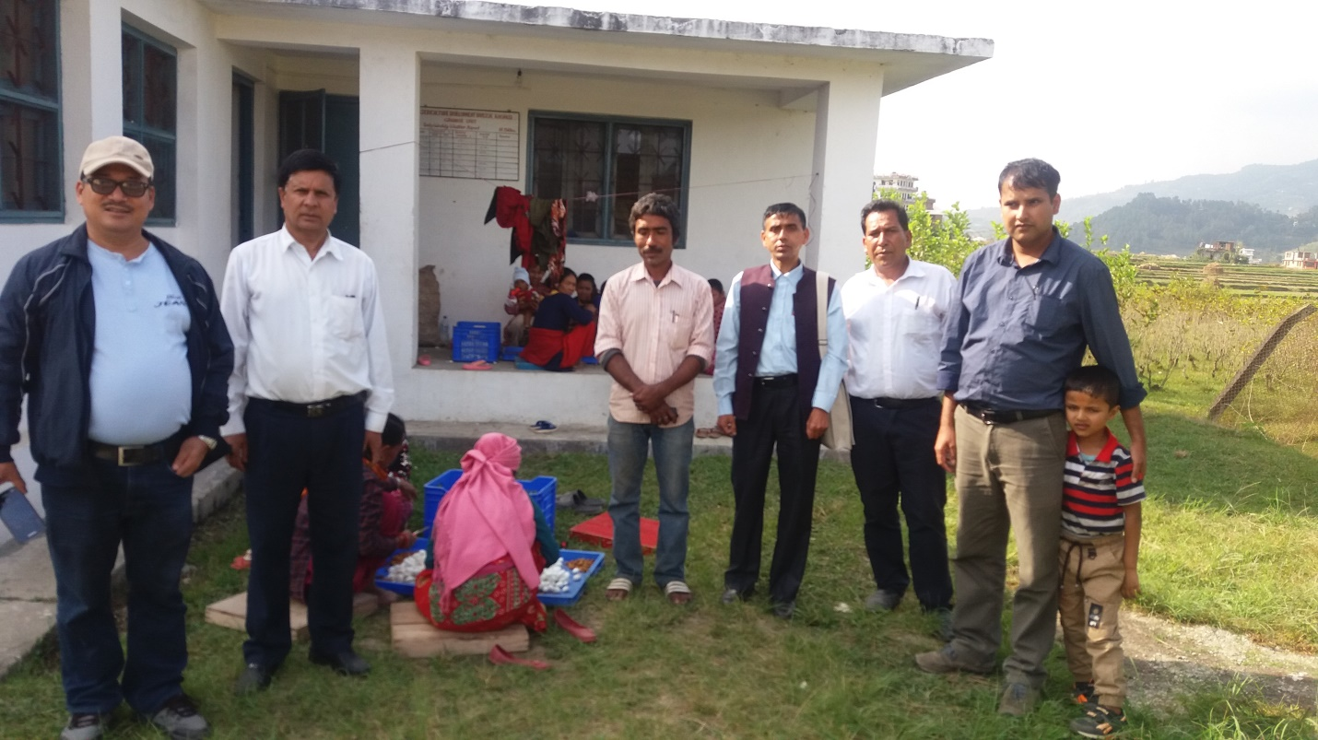
rfn' sfo{qmd÷ultlalw / cj:yf
!= /]zddft[;|f]t ;+/If0f
- o; s]Gb|df lsDa' /]zdsf b'O{k':t] -Bivoltine_ / ax'k':t] -Multivoltine_ k|hflt ;d]t #% lsl;dsf /]zd k|hfltx¿sf] ;+/If0f ug]{ sfo{ ;'rf? /x]sf] 5 .
- w]/} jif{ cl3b]lvsf dft[;|f]t x'gfn] Pureline productiondf s]xL Mixed up Problem b]lvPsf] / hflto u'0f:t/df x|f; cfPsf] b]lvG5 .
- h}ljs k|of]zfnf cfwfl/t sfo{ x'gfn] lgolGqt jftfj/0f Joj:yfkg ug{ lg/Gt/ ljh'nL cfk"lt{ x'g'kg]{ / o;df xfn u8a8L x'Fbf ;d:of b]lvPsf] 5 .
- ;DalGwt k|of]uzfnf ;fdu|L tyf pks/0fx¿ w]/} k'/fgf / hL0f{ e};s]sf] b]lvG5 .
- e"sDksf sf/0f k|of]uzfnf ejgx¿df uxg Iflt k'u]sfn] klg o;sf] Joj:yfkgdf lgs} sl7gfO b]vf k/]sf] hfgsf/L eof] .
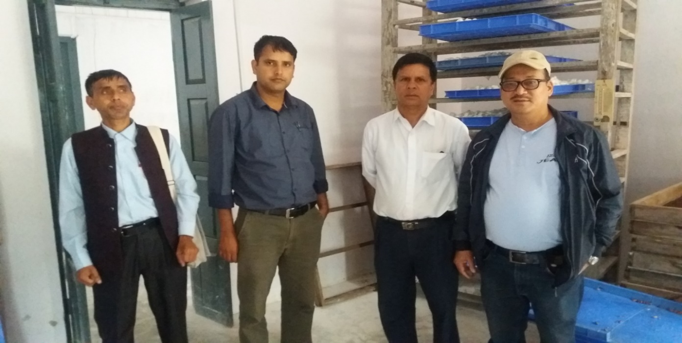
@= kmfd{ Joj:yfkg tyf lsDa' hflto ;|f]t ;+/If0f
s]Gb|sf] kmfd{df ljleGg hftsf lsDa' dft[>f]tsf] ;+/If0f e}/x]sf] 5 . lsDa' ju}Frfsf] cj:yf TolQ ;Gtf]ifhgs b]lvPg . au}Frfsf] Joj:yfkgdf Jofks ;'wf/ cfjZos b]lvPsf] 5 . ljz]if u/L kof{Kt l;rfO{ / kf]if0fsf] sdL tyf ;dofg's' sfF65f7 Joj:yfkgdf sdL ePsf]n] ju}Frfx¿sf] x|f; x'b} uPsf] b]lvG5 .
#= /]zd aLh pTkfbg
- ljleGg /]zd kmfd{ s]Gb| tyf s[ifsx¿sf] dfusf cfwf/df o; s]Gb|df /]zdsL/fsf] aLh -k'mn_ pTkfbg / cfk"lt{ ug]{ sfo{ ;'rf? 5 .
- of] s]Gb| xfn b]zleqsf] /]zdaLhsf] dfu k"/f ug{ ;Ifd /x]sf] 5 .
- t/, o;sf nflu vf]kf;Ldf dfq pTkflbt aLhsf]ofaf6 dfq kof{Kt gx'g] x'gfn] cGo /]zd kmfd{ s]Gbx¿ -w'gLj]zL, aGbLk'/, kf]v/f, :ofª\hf, cflb_af6 aLhsf]of ;+sng u/L To;af6 /]zd k'tnL lgsfn]/ k'mn -/]zdaLp_ pTkfbg ug]{ ul/Psf] 5 . xfn pQm kmfd s]Gb|x¿ k|b]z ;/sf/ dftxt /xg] x'gfn] of] sfo{qmdf k|ToIf k|efljt x'g ;Sg] b]lvPsf]n] o;sf nflu cfjZos ;dGjofTds Joj:yf ug'{kg]{ b]lvG5 .
- C₁₂J₁₂ k|hfltsf] xfOa|L8 aLp pTkfbgsf ;fy} $ j6f Raceaf6 aLp lgsfNg] ul/Psf] 5 eg] afFsL k|hfltx¿sf] ;+/If0f dfq ul/Psf] 5 .
- ejgx¿ hL0f{ / d]lzg pks/0fx¿ @@–@% jif{ k'/fgf x'gfn] lgs} sl7gfO /x]sf] .
- o;sf nflu cGo ;DalGwt /]zd kmfd{s]Gb|n] /]zd aLhsf]of pTkfbg sfo{qmd clgjfo{ /fVg] / vf]kf;Ldf ;xh ¿kdf k7fpg] Joj:yf ldnfOg'kg]{ .
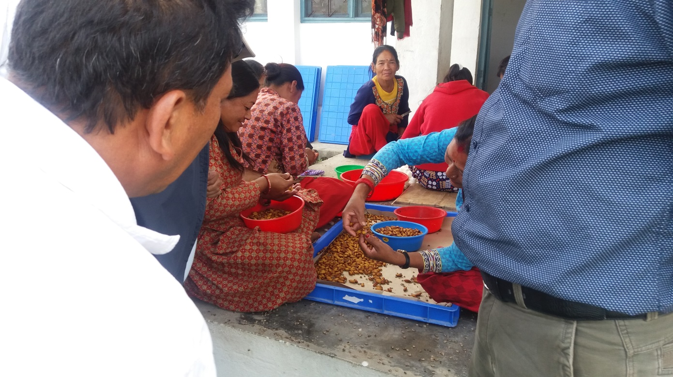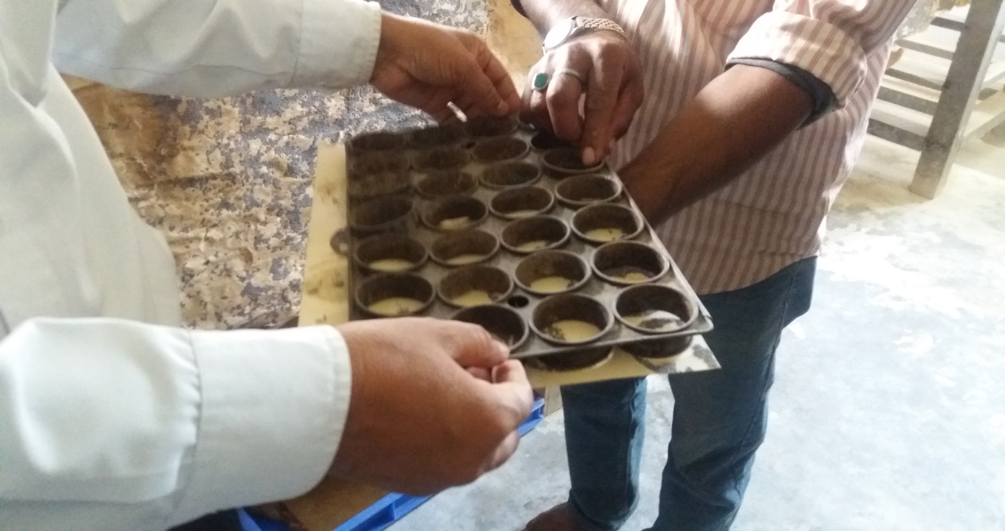
$= hgzlSt ljsf; / k|fljlws ;]jf6]jf
/]zdv]tL jf Jofj;fodf ;+nUg s[ifs, k|flalws tyf Jofj;foL pBdLsf nflu tflnd tyf ;]jf6]jf sfo{qmd /flvg' kg]{df o; cf=j=sf] sfo{qmd jh]6df gePsf] . cfufdL cf=j=sf] sfo{qmd jh]6 th'{dfdf Joj:yf ul/g'kg]{ .
%= cGo sfo{qmd÷ultlalw
- /]zd wfuf] sfTg] ;fdfGo k|bz{gsf ultljle ;+rflnt eP klg To; s]Gb| :yflkt cfw'lgs ;'lawfo'St Silk Reeling sf/vfgf tyf d]l;gx¿ pknAw eP klg xfn ;'rf? gePsf] tyf gfh's tyf hL0f{ cj:yfdf /x]sf] kfOof] .
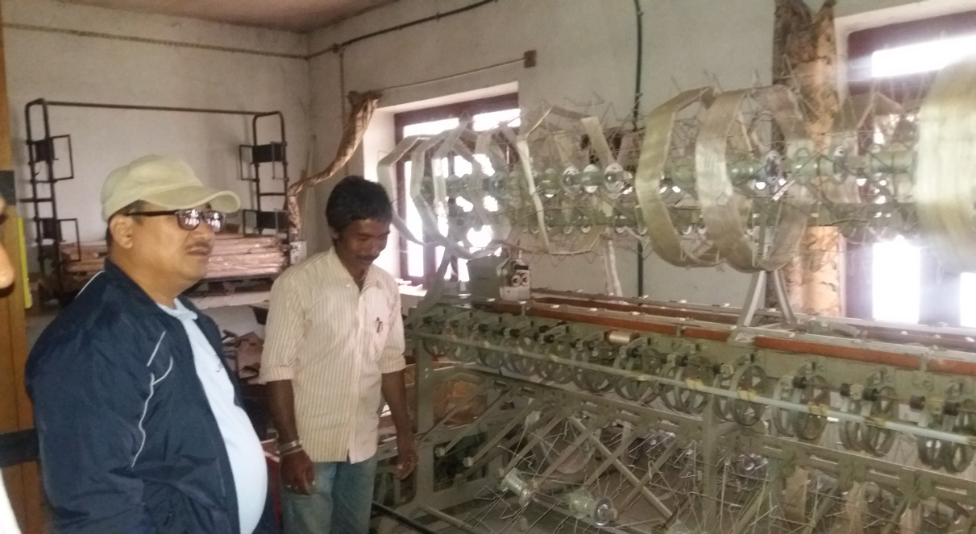
- bfª lhNnfdf xfn sl/j !)) x]S6/ hldgdf lsDa'v]tL lj:tf/ ePsf] o; s]Gb|sf] ;d]t ;dGjo /x]sf] hfgsf/L eof] .
- k'hLut sfo{qmdtk{m ;'Vvf df};ddf Multi-voltine racesf /]zdls/fkfnsf nflu lsDa'sf] kft ;+/If0f ug{ u|Lg xfp; lgdf{0f ug'{kg]{ .
- !& hgf sf] hgzlSt bj{GbL /x]sf]df afnL ;+/If0f clws[t / sf=;=x¿ ;d]t $ hgfsf] bj{GbL l/St /x]sf]n] sfo{ ;Dkfbgdf cK7]/f] k/]sf] .
- n]vfkfn / gf=;'= s]Gb|df xfn;Dd kmflhndf xflh/ /x]sf] cj:yf / tnj ;DaGwL / k|zf;lgs tslnkm /x]sf] .
-v_ cfn'afnL ;'k/ hf]g, ag]kf, sfe|]
k|wfgdGqL s[lif cfw'lgsls/0f cfof]hgf cGt/ut, cfn'afnL ;'k/hf]g sfof{no lg/LIf0f ul/of] . sfe|]sf k|d'v bLks kf}8]n / s[lif clws[t dw';'wg l3ld/] nufot To; ;'k/hf]gdf sfo{/t sd{rf/LaLr cGt/lqmofTds 5nkmn eof] . canf]sg lg/LIf0f tyf cGt/lqmofaf6 lgDgfg';f/ hfgs/L pknAw eof] .
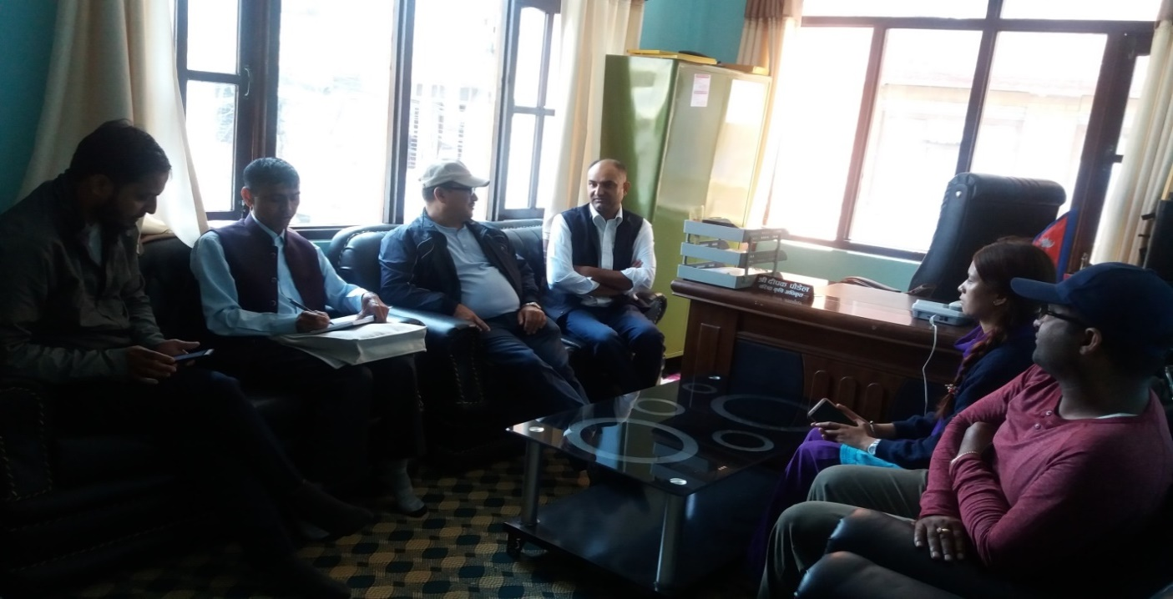
-cfn' ;'k/hf]gsf sd{rf/Lx¿;Fu cGt/lqmofTds 5nkmn ._
;+rflnt d'Vo ultlalwx¿
- ;fgf l;FrfO{ ;xof] sfo{qmd -!))) x]=df, @) j6f_ – & g=kf=÷uf=kf=df
- /li6s 3/ lgdf{0f, cfn' lrK; pBf]u ;xof]u – cg'bfgdf d]lzg/L lbg], esf/f] ;'wf/, kf]i6 xfe]{i6 ;]G6/ agfpg ;xof]u ug]{, s[lif cf}hf/ tyf d]lzg/L pks/0f cg'bfg ;xof]u, r'g / cfn' aLpdf cg'bfg,cflb .
;d:of / ;'emfjx¿
- ;DalGwt kflnsf / ;'k/hf]gsf] ;dGjo ;xh eOg;s]sf] b]lvG5 . t;y{, ;'k/hf]g sfo{qmd ;DaGwdf ;xeflutfTds cGt/lqmof / ;xsfo{ h?/L b]lvG5 . cfof]hgfsf sfo{qmd ultlalwdf g=kf=÷uf=kf= sf s[lif k|flalws :6fkm;Fu ;dGjo ub}{ sfo{qmd dfk{mt pgLx¿nfO{ klg Mobilize ug'{kg]{ b]lvG5 . o;af/] s[lif ljefun] klg ;f]Rg'kg]{ / cfjZos lgb]{zg / ;xhLs/0f ug'{kg]{ dx;'; ul/of] .
- ;'k/hf]gaf6 ;+rflnt sfo{qmd ultlalwx¿df kmfd{ s]Gb|x¿nfO{ ;d]t ;dfj]z ug]{ / ;fljs s[lif ljsf; sfof{nodfk{m kl/rflnt :yfgLo s[ifs ;d"xx¿nfO{ klg ;DalGwt ;'k/hf]g sfo{qmddfk{mt ;DaGw hf]8\g] k|of; x'g' h?/L 5 .
- ;'k/hf]g sfo{qmdnfO{ k|efjsf/L agfO{ cfn'afnLnfO{ cf}Bf]lus ¿kfGt/0f ug{ s[lif ljefu÷dGqfnon] sfo{ut tyf gLltut kyk|bz{g ug'{ cfjZos 5 .
- s[lif ljefuaf6 ;+rfng x'g] k|fª\ufl/s v]tL ;DaGwL sfo{qmddf ;DalGwt hf]g ;'k/hf]gnfO{ klg ;xefuL agfPdf sfo{qmdsf] k|efjsfl/tf a9\g;Sg] ;'emfj k|fKt .
-u_ s[lif 1fg s]Gb|, w'lnv]n, sfe|]
;fljs lhNnf s[lif ejgdf gofF s[lif ;+/rgf cg';f/sf] s[lif 1fg s]Gb|sf] :yfkgf x'g] / jf]8{ ;d]t /flvPsf] eP klg lg/LIf0f cjlw;Dddf ljlwjt sfo{no ;+rfng ePsf] lyPg . ToxfF pkl:yt lji0f' clwsf/L / s]zj sf]O/fnf ;d]t sd{rf/L;Fu cGt/lqmof x'Fbf lgDgfg';f/ hfgsf/L k|fKt eof] .
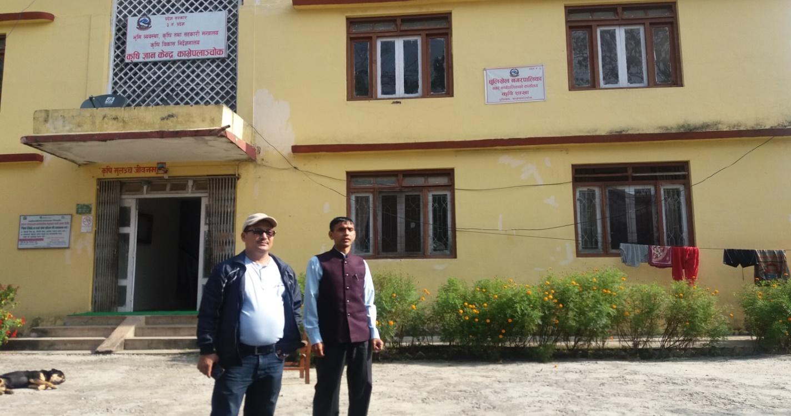
- ;ft hgf sf=;= ;d]t s]xL sd{rf/L 7f8f] xflh/Ldf ;fljs lh=s[=lj=sf= df /x]sf] cj:yf .
- s[lif 1fgs]Gb|df k|d'v ;d]t !& hgfsf] b/jGbL /x] klg n]vfkfn afx]s 1fgs]Gb|sf cGo sd{rf/Lsf] cflwsfl/s kq k|fKt gePsf] .
- sd{rf/Lsf] tnj vfg] Joj:yf eOg;s]sfn] rf8jf8sf] ;dodf sd{rf/Lsf] lk8fbfoL u'gf;f] ;'Gg] sfd eof] .
- s[lif ;]jf s]Gb|x¿ :yfgLo txdf x:tfGt/0f e};s]sf] / sltkodf cGo sfof{no ;d]t a;]sf] cj:yf af/] hfgsf/L eof] .
- oyfzL3| 1fgs]Gb| tyf ;DalGwt s[lif sfof{no tyf kmfd{s]Gb|x¿sf] sd{rf/L Joj:yfkg u/L ljlwjt\ sfo{qmd ;+rfng ug'{ h?/L b]lvG5 .
lgisif{ tyf ;'emfj÷l;kmfl/;
!= gofF ;+u7g ;+/rgfdf /]zdv]tL ljsf; s]Gb| ;ª\3 cGt/ut, t/ cGo /]zd kmfd{ s]Gb|x¿ k|b]z cGt/ut k/]sfn] ;dGjofTds sfo{qmd sfof{Gjogdf sl7gfO kg{ ;Sg] b]lvG5 . ljz]if u/L, /]zdaLh pTkfbg sfo{qmd ;'rf? ug{ cGo kmfd{ s]Gb|af6 aLhsf]of Nofpg'kg]{ ePsfn] ;DalGwt /]zd kmfd{÷s]Gb|nfO{ klg ;ª\3 cGt/ut g} /fVg pko'Qm x'g] b]lvG5 .
@= kof{Kt sfo{qmd ah]6 gePsfn] k'/fgf au}Frf Joj:yfkg nufotsf lgoldt sfo{ ;Dkfbgdf ;d:of b]lvPsfn] cfufdL lbgdf kof{Kt sfo{qmd ah]6 /fvL k|efjsf/L sfof{Gjo Joj:yf ug'{ h?/L 5 .
#= /]zd l/lnË -wfuf] pTkfbg_ sf/vfgfdf ljutb]lv cTofw'lgs k|lalwsf d]lzg pks/0fx¿ pknAw eP klg xfn hL0f{ cj:yfdf /x]sf] / ;'rf? x'g g;s]sf]n] o;sf] dd{t u/L ;'rf? ug]{ sfo{qmd, ah]6 / hgzlStsf] kof{Kt Joj:yf ug'kg]{ b]lvG5 . cyjf, o;nfO{ ;'rf? ug{ lghLIf]qsf /]zd pBdL÷Jofj;foL;Fu ;xsfo{df eP klg sf/vfgf ;'rf? ug]{tkm{ s]Gb|Lo:t/d} cfjZos ;f]r ljrf/ u/L lg0f{o lng'kg]{ b]lvG5 . cfly{s ;d[l4sf] k|r"/ ;Defjgf ePsf] ljifo / ;Dkbf ePsf]n] o;sf] ;b'kof]u÷;'rf? ug]{tk{m Wofg lbg' lgtfGt h?/L 5 .
$= e"sDksf sf/0f k|of]uzfnf ejgx¿df uxg Iflt k'u]sfn] o;sf nflu cfjZos sfo{qmd ah]6 th'{df u/L sfof{Gjog ug'{kg]{ b]lvG5 .
%= /]zd aLh pTkfbg sfo{nfO{ k|efjsf/L ¿kdf ;'rf? /fVg cGo ;DalGwt /]zd kmfd{s]Gb|x¿n] klg /]zd aLhsf]of pTkfbg sfo{qmd clgjfo{ /fVg] / ;xh ¿kdf vf]kf;Ldf k7fpg] Joj:yf ldnfOg'kg]{ b]lvG5 .
^= /]zdv]tL jf Jofj;fodf ;+nUg s[ifs, k|flalws tyf Jofj;foL pBdLsf nflu ;dofg's'n tflnd tyf ;]jf6]jf sfo{sf nflu cfufdL cf=j=sf] sfo{qmd jh]6df Joj:yf ul/g' h?/L 5 .
&= ;'k/hf]gaf6 ;+rflnt sfo{qmd ultlalwx¿df kmfd{ s]Gb|x¿nfO{ ;d]t ;dfj]z ug]{ / ;fljs s[lif ljsf; sfof{nodfk{mt kl/rflnt :yfgLo s[ifs ;d"xx¿nfO{ klg ;DalGwt ;'k/hf]g sfo{qmddfk{mt ;DaGw hf]8\g] k|of; x'g' h?/L 5 .
*= s[lif ljefuaf6 ;+rfng x'g] k|fª\ufl/s v]tL nufotsf k|j4{g sfo{qmddf ;DalGwt hf]g÷;'k/hf]gnfO{ klg ;xefuL agfpg' pko'Qm x'g]5 .
k|ltj]bg k|:t'tstf{ M
tf/f s'df/ >]i7, pk–dxflgb]{zs, s[lif ljefu .
8f= km0fLGb|/fh b]jsf]6f, jl/i7 afnL ;+/If0f clws[t, s[lif ljefu .
lul/k|;fb ahufO{F, ;jf/L rfns, s[lif ljefu .

